Lab Experiment: 6

Title: Interfacing LCD with Arduino to Display Temperature using LM35 Sensor
Course title: IOT Laboratory

Course code: CSE-460
4th Year 1st Semester Examination 2025

Date of Submission: 30/03/2026

Submitted to-

Dr. Md. Ezharul Islam, B.SC.(JU), M.ENGG.(JAPAN), PHD(JAPAN)
Professor
Department of Computer Science and Engineering
Jahangirnagar University

&

Samsun Nahar Khandakar
Assistant Professor
Department of Computer Science and Engineering
Jahangirnagar University
Savar, Dhaka-1342

Class Roll | Exam Roll | Name
383 | 210903 | Abdullah Nazmus-Sakib
379 | 210899 | Shah Sultan
391 | 210911 | Md Khaled Mahmud

📘 1. Title
Interfacing LCD with Arduino to Display Temperature using LM35 Sensor

🎯 2. Objective
- To interface a 16x2 LCD with Arduino
- To read temperature data from LM35 sensor
- To display real-time temperature on LCD
- To understand analog input and display output

🧰 3. Components Required
Component | Quantity
Arduino Uno | 1
16x2 LCD Display | 1
LM35 Temperature Sensor | 1
Potentiometer (1k–10k) | 1
Jumper wires | As required
Breadboard | 1

🔌 4. Circuit Connection

🔹 LM35 Sensor Connection
- Pin 1 → 5V
- Pin 2 → A0 (Analog input)
- Pin 3 → GND
📌 As shown in the diagram (page 1), LM35 provides analog voltage output

🔹 LCD Connection
- RS → Pin 12
- E → Pin 11
- D4–D7 → Pins 5, 4, 3, 2
- VSS → GND
- VDD → 5V
- V0 → Potentiometer (contrast control)

📌 The full wiring layout is illustrated in the circuit diagram (page 2)

💻 5. Program (Arduino Code)
#include <LiquidCrystal.h>

int sensorpin = A0;
int temperature = 0;

LiquidCrystal lcd(12, 11, 5, 4, 3, 2);

void setup() {
pinMode(sensorpin, INPUT);
lcd.begin(16, 2);
lcd.print("Temperature:");
}

void loop() {
temperature = analogRead(sensorpin);
temperature = temperature * 0.48828125;

lcd.setCursor(0,1);
lcd.print(temperature);
lcd.print((char)223); // degree symbol
lcd.print("C");
}

⚙️ 6. Working Principle
- LM35 sensor outputs voltage proportional to temperature
- Arduino reads analog value (0–1023)
- Value is converted to temperature using formula:
Temperature (°C) = Analog Value × 0.48828125
- LCD displays temperature in real-time
- Potentiometer controls LCD contrast

▶️ 7. Procedure
- Collect all required components
- Connect LM35 sensor and LCD as per diagram
- Connect Arduino to computer
- Open Arduino IDE
- Write or paste the code
- Select correct board and port
- Upload the program
- Observe temperature displayed on LCD

📊 8. Observation
- LCD displayed “Temperature:” on first line
- Second line showed real-time temperature value
- Value changed when temperature around sensor changed
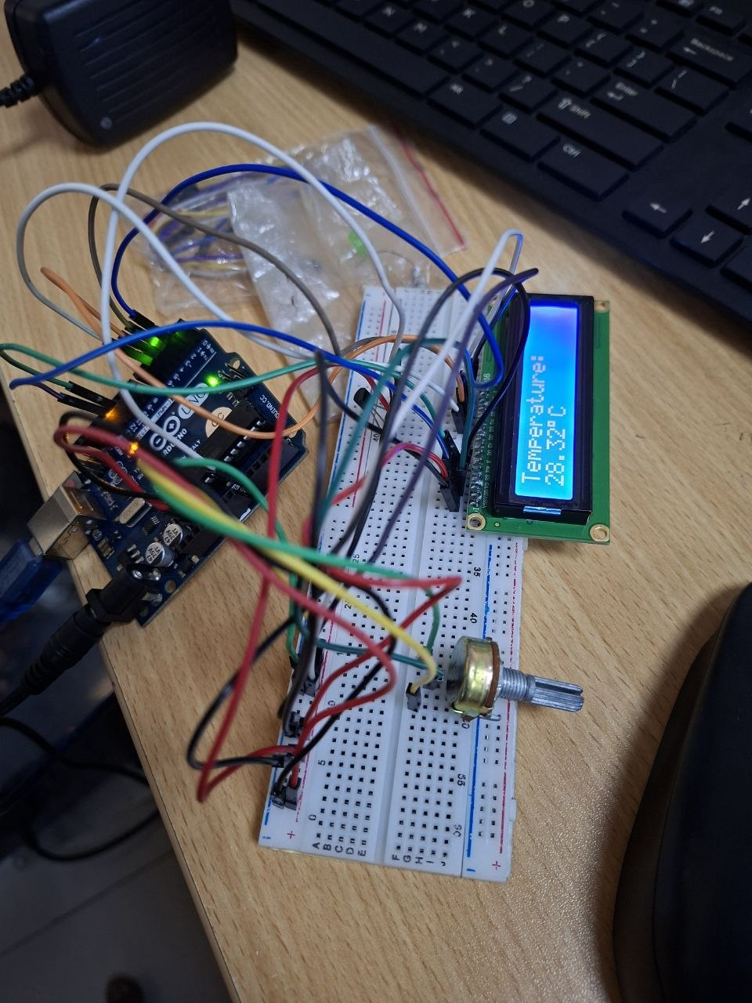

📈 9. Result

The temperature measured by LM35 sensor was successfully displayed on the LCD in real-time, demonstrating proper interfacing of sensor and display module with Arduino.

🧠 10. Applications
- Digital thermometers
- Weather monitoring systems
- Smart home automation
- Industrial temperature monitoring
- IoT display systems

⚠️ 11. Precautions
- Ensure correct LCD pin connections
- Adjust potentiometer for proper display visibility
- Avoid loose wiring
- Use correct power supply
- Do not overheat LM35 sensor

🏁 12. Conclusion
This experiment demonstrated how to interface both an input device (LM35 sensor) and an output device (LCD) with Arduino. It provided a clear understanding of analog data acquisition and real-time display, which are essential concepts in embedded systems and IoT applications.

